Thank you for filling out the following application for an instructor position at the Cooking School at Irwin Street. Because we get many qualified inquiries a day we cannot guarantee you a spot, but if we are a mutually good fit, we’ll keep your application on file.

What we’ll need from you:

A fully complete and accurate application

Experience cooking and teaching

Availability for some nights and weekends

Smooth and timely communication

Time to interview and show your our facility

All answers will be kept confidential. If for some reason you do not want us to contact your current employer or supervisor for a reference, please be prepared to let us know this and why. We try very hard to properly vet anyone we put in front of our students.

We require all instructors to sign a mutual Non-Disclosure Agreement. If you are accepted you will be expected to adhere to our policies regarding scheduling, building security, cleanliness and sanitation. We will provide you with a comprehensive list of our policies if we approve your application (and before you sign any agreements with us).

If you have any questions, please do not hesitate to ask. We are here to help you make the best decision for you.

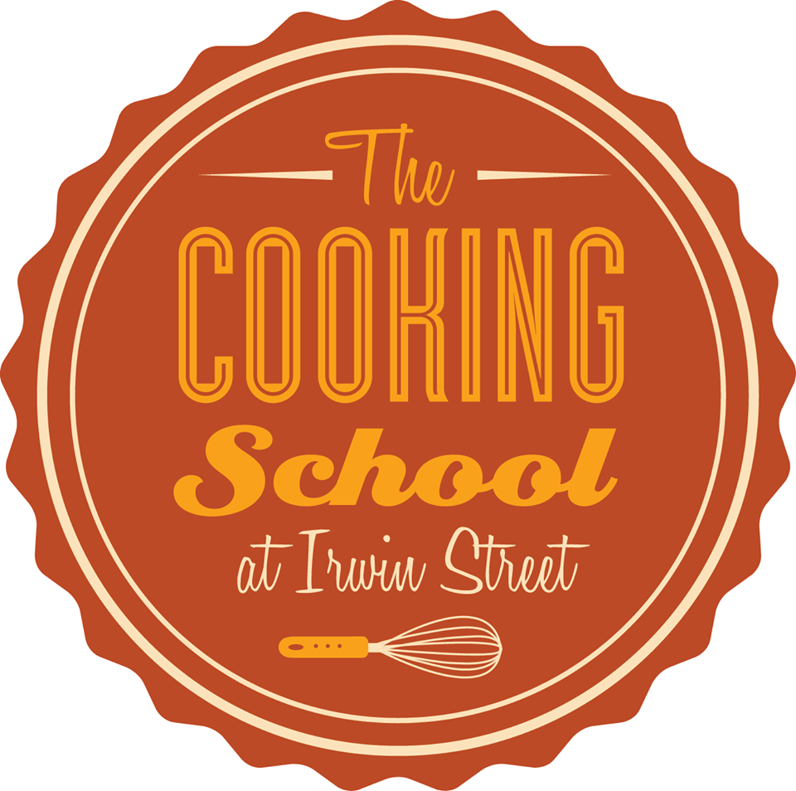

The Cooking School at Irwin Street

Instructor Application
Date: _______________
Please email this application in confidence to jdratlanta@gmail.com or mail it to:
The Cooking School at Irwin Street
660 Irwin Street
Atlanta, Georgia 30312
Attn: Jake Rothschild
Pertinent Information
Name(s) (Last) (First) (Middle)
________________________________________________________________________
________________________________________________________________________
________________________________________________________________________
Mailing Address (Street) (City) (State) (Zip)
_________________________________________________________________________________
Permanent Address (Street) (City) (State) (Zip)
_________________________________________________________________________________
Home Telephone (including area code) Work Telephone (or other number at which
you can be reached)
_____________________________________________ ____________________________________
How did you hear about The Cooking School at Irwin Street opportunities? __________________________________________________________________________________
What do you currently do for a living?
__________________________________________________________________________________

Your Interest in The Cooking School at Irwin Street
What prompted you to seek information about our program?
Please check all that apply.
Curiosity from recent press
Referral from another instructor
Word of mouth
Other
What timeframe are you considering?
ASAP 3 to 6 months 12 months Other _______________________________ __________________________________________________________________________________
What kind of menus are you comfortable teaching?
_________________________________________________________________________________ _________________________________________________________________________________
What is the best time of day/evening for you teach?____________________________________________________________
Please us more about your availability________________________________________________
Have you taught in this kind of setting before?____________________________________________________________________________________________________________________________________________________________________
Do you have experience in team building?______________________________________
_________________________________________________________________________________

